**HISTORICAL FIGURE/ EVENT WEBSITE**



A Project Documentation Submitted to the College of Information TechnologyCagayan de Oro College PHINMA Education

In Partial Fulfillment of the Requirements for Human Computer Interaction I

**Submitted by:**

Cahayag, Chino Bill

Candelario, Christian

Edlang, Frenz Jerald

Indoc, Johnpaul

Martinez, Jowen

Montelliero, Francis Adrian

Santua, Earl Dan

Section:

COC-FA1-IT1-01

April 2025

**INTRODUCTION**

**Welcome to our Historical Figures and Events website—a place where the past comes alive. This platform is dedicated to helping you explore the people and moments that have shaped the world we live in today .Here, you’ll find detailed profiles of important historical figures from all over the globe. From world leaders and inventors to activists and artists, each story highlights their contributions and lasting impact on history. In addition to biographies, our website features key historical events that changed the course of nations. Timelines, photos, and original sources help bring each moment to life in an engaging and informative way. Whether you're a student, teacher, or just someone who loves history, our goal is to make learning the past easy and exciting. Start your journey now and discover how history continues to influence our present and future.**

**Wireframe**

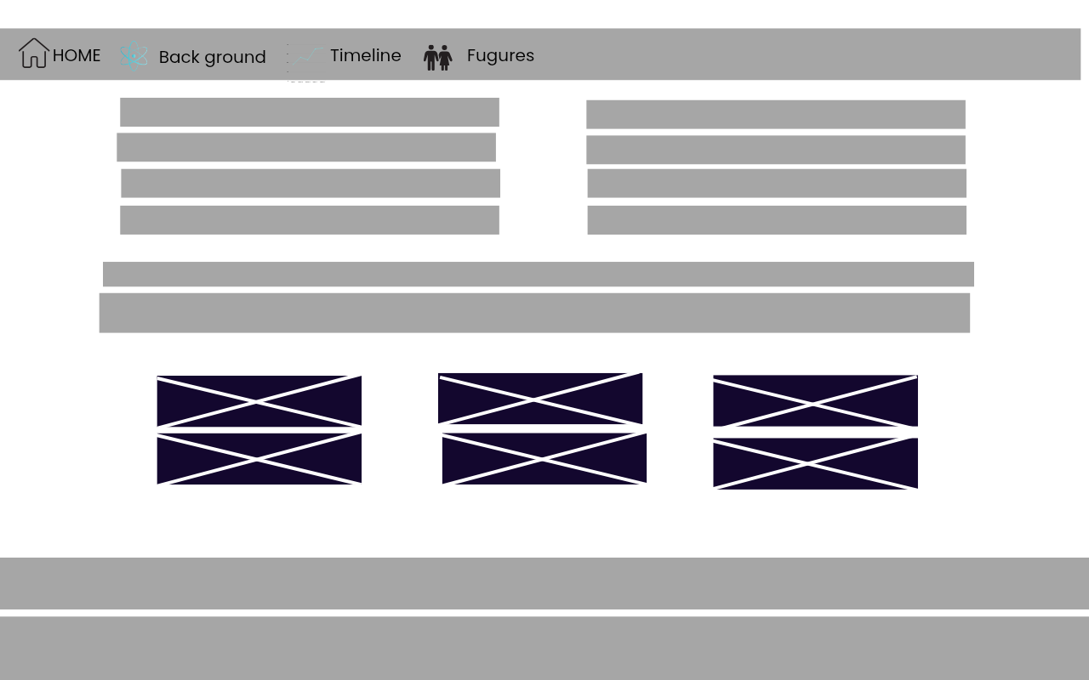

**Website Screenshot**

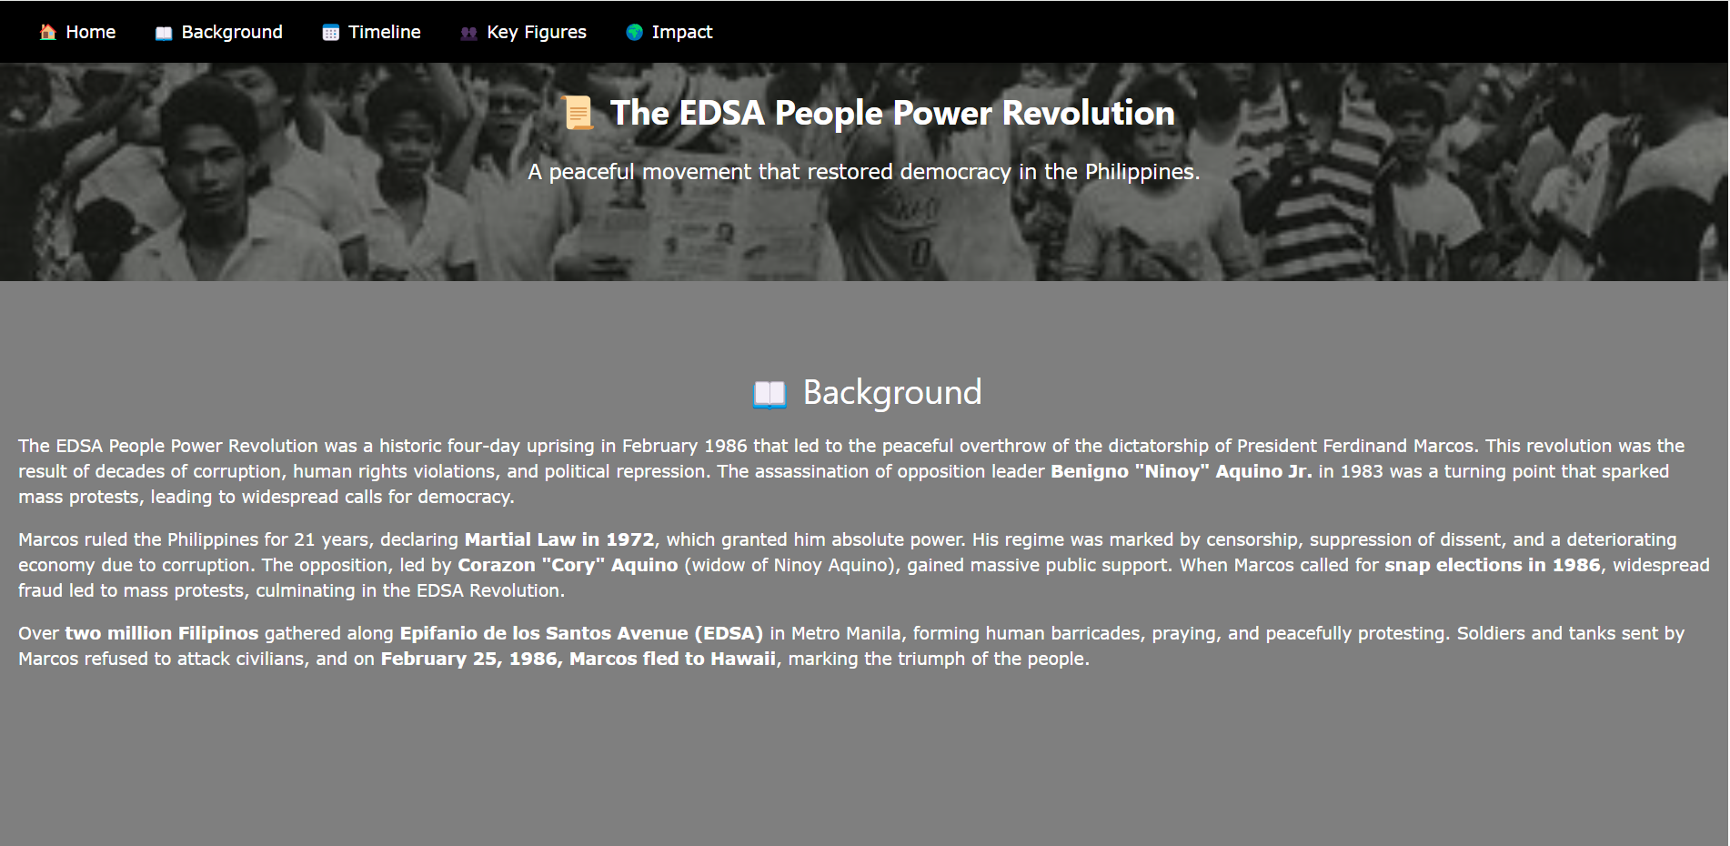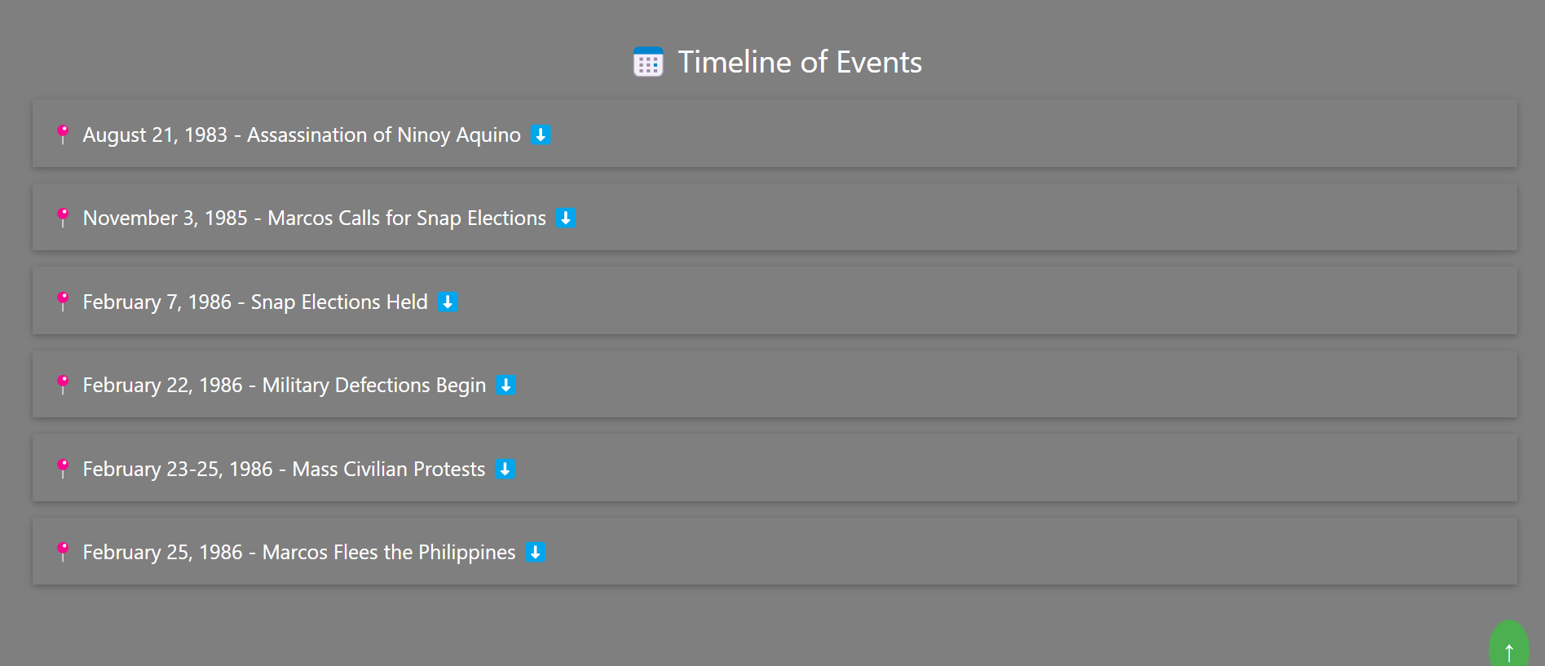

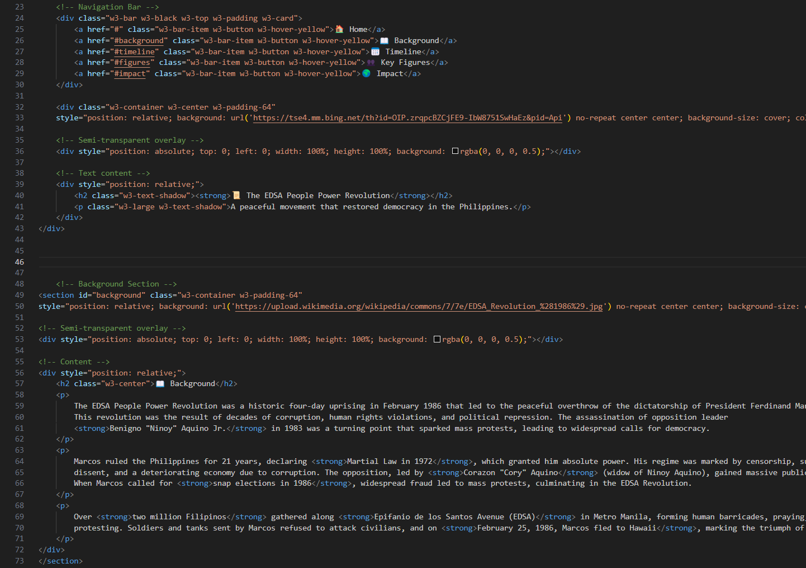

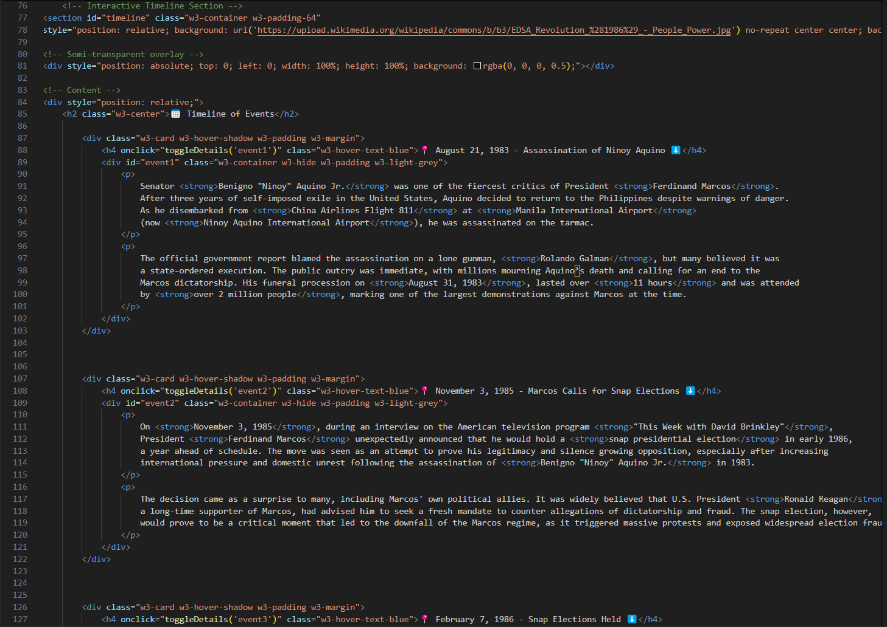

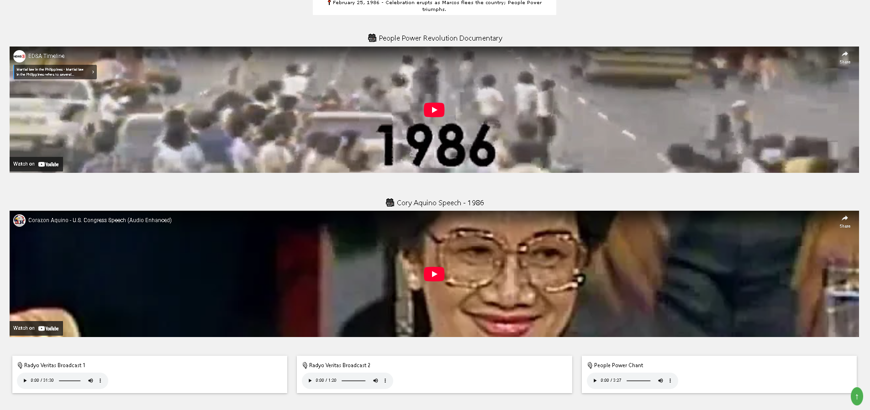

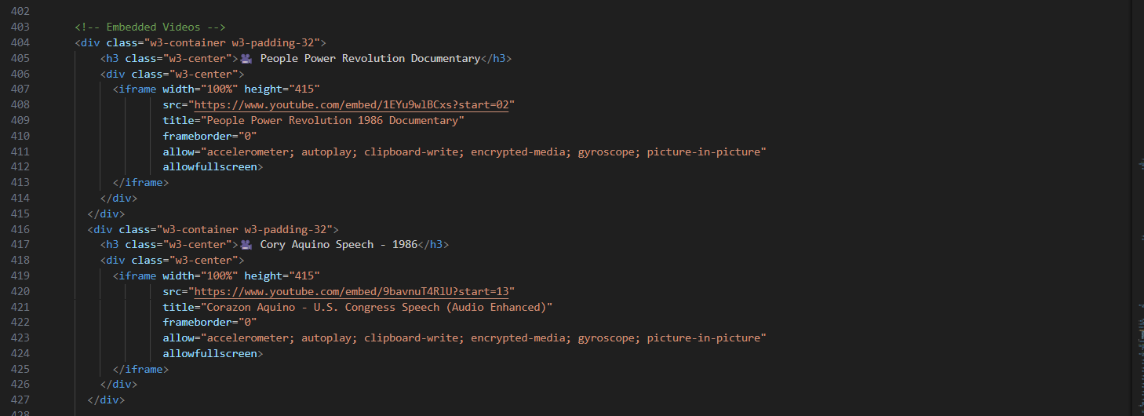

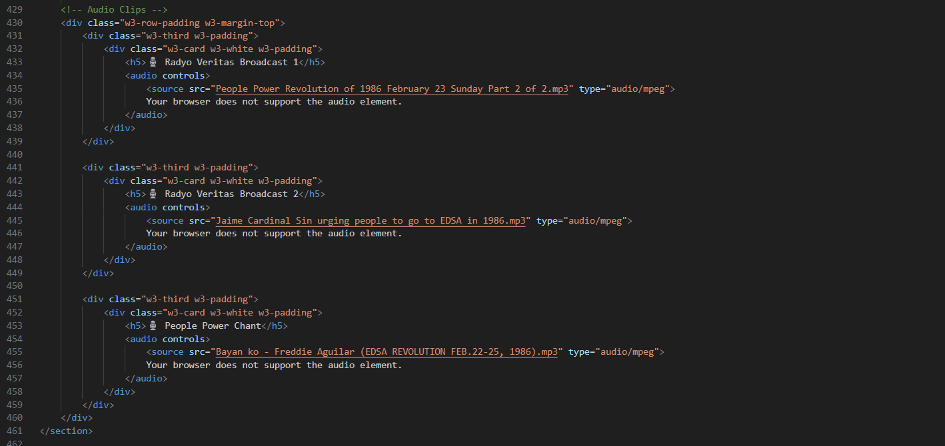

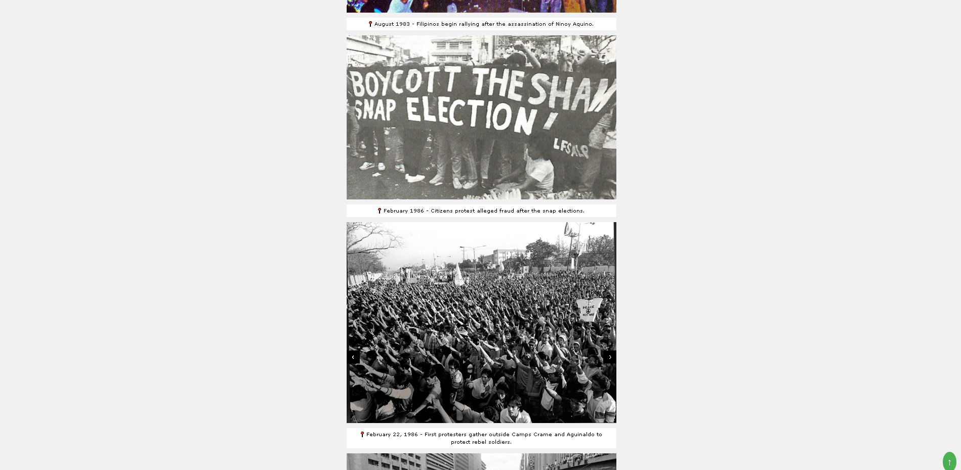

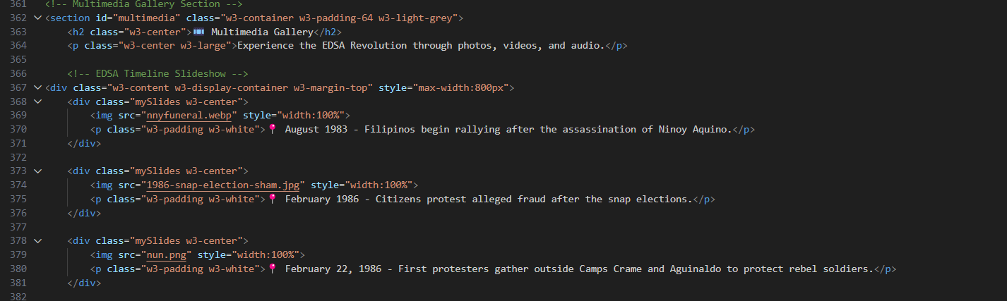

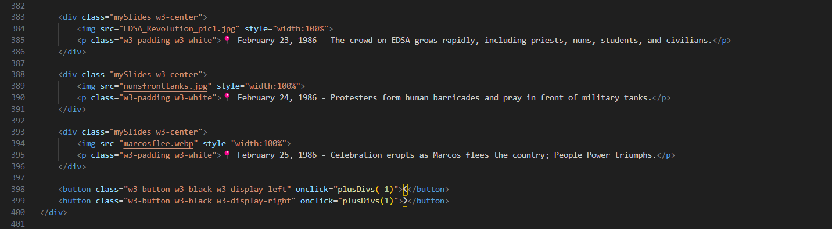

**Photo documentation**

